**Week One Practice Note!**

Here is my code preview and my simple portfolio

1. Portfolio webpage

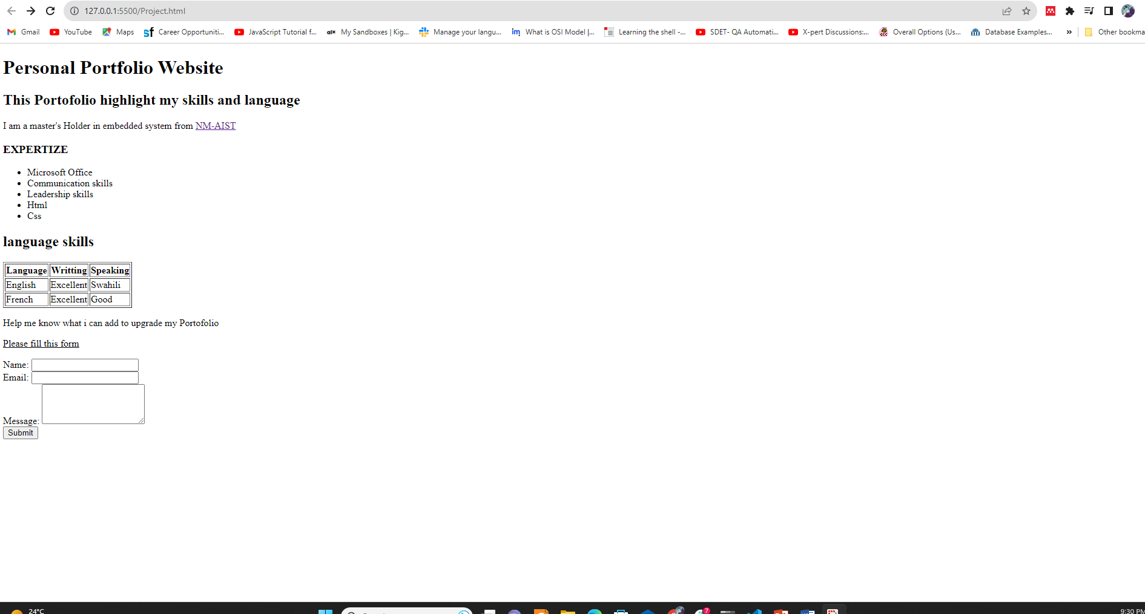

2. Used Code

<!DOCTYPE html>

<html lang="en">

<head>

    <meta charset="UTF-8">

    <meta name="viewport" content="width=device-width, initial-scale=1.0">

    <title>Personal Portfolio Website</title>

</head>

<body>

    <h1>Personal Portfolio Website</h1>

    <h2>This Portofolio highlight my skills and language</h2>

    <p>I am a master's Holder in embedded system from <a href="https://nm-aist.ac.tz/">NM-AIST</a></p>

    <h3>EXPERTIZE</h3>

    <ul>

        <li>Microsoft Office</li>

        <li>Communication skills</li>

        <li>Leadership skills</li>

        <li>Html</li>

        <li>Css</li>

    </ul>

    <h2> language skills</h2>

    <table border="1">

        <tr>

            <th>Language</th>

            <th>Writting</th>

            <th>Speaking</th>

        </tr>

        <tr>

            <td>English</td>

            <td>Excellent</td>

            <td>Swahili</td>

        </tr>

        <tr>

            <td>French</td>

            <td>Excellent</td>

            <td>Good</td>

        </tr>

    </table>

<p>Help me know what i can add to upgrade my Portofolio</p>

<p><u>Please fill this form</u></p>

<form action="" method="post">

    <label for="name">Name:</label>

    <input type="text" id="name" name="name" required>

    <br>

    <label for="email">Email:</label>

    <input type="email" id="email" name="email" required>

    <br>

    <label for="message">Message:</label>

    <textarea id="message" name="message" rows="4" required></textarea>

    <br>

    <input type="submit" value="Submit">

</form>

</body>

</html>